**TEST REPORT – 06.10.2023** [**https://www.pothys.com/**](https://www.pothys.com/)

**iPad-Closed Issues:**

1, Quantity button alignment needs to be fixed in iPad UI

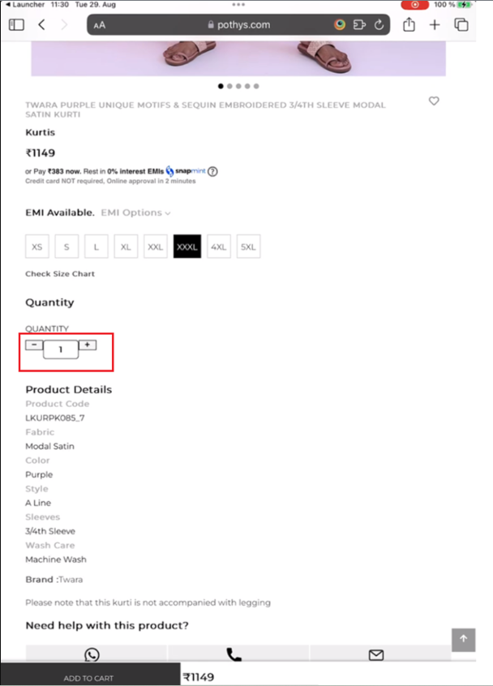

**Fixed:**

2, Quantity header present two times. Remove the duplicate globally.

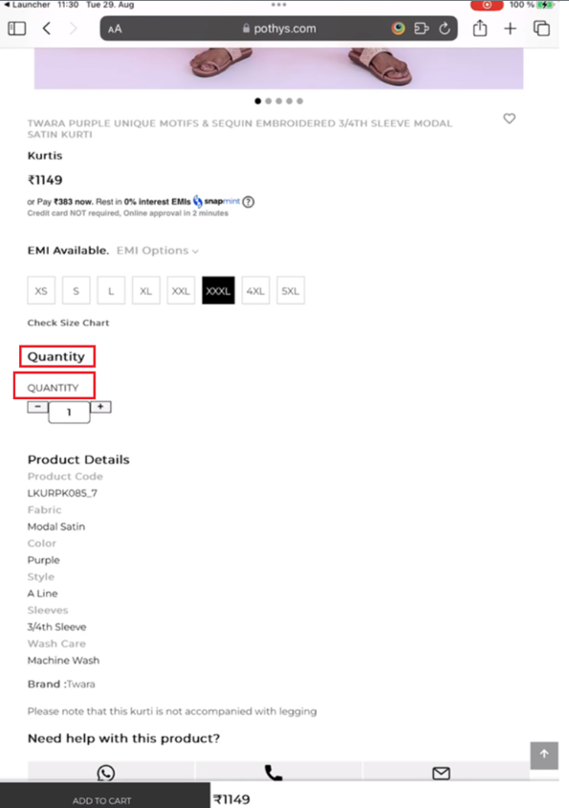

**Fixed:**

3, Remove the unwanted space in the main categories band in portrait /landscape modes.



**Fixed:**



